高考英语复习自选训练 阅读理解37

Brian knew he had been drinking more and more, but he was convinced that he'd return to more moderate drinking when he wasn't so pressured at work, and that "a few too many drinks now and then" wasn't a major problem.
"My wife and father were on me to stop drinking, but you know how critical and protective family can be," said Brian. "So I blew them off."
It wasn't until his friend Jack spoke up that Brian started to think differently. "That really hit home, because I wouldn't expect a friend to confront me with something that personal unless it was very important," said Brian. "Jack said he was really concerned about me. He pointed out that my personality changed after I had a few beers--that I became belligerent(寻衅的). For a normally easy-going guy, that was a dramatic change in behavior."
Jack could see that Brian's numerous drinking binges(放纵) were causing problems. Brian was frequently calling into work sick and falling behind in his work, and his marriage was seriously on the ropes. Brian was teetering on the edge of disaster. "I didn't want to see a good life and a good friendship ruined," said Jack, "so I approached Brian, shared my honest observations with him, and suggested that he seek help."
After a couple days of soul searching, though still reluctant, Brian took Jack's suggestion and was assessed by an addiction professional. The expert recommended that Brian check into a treatment center, and one day later Brian did so.
Many people fear taking the path that Jack took. Speaking up to a friend who may have a problem with alcohol or other drugs can be a tricky undertaking.
Yet it's true that a concerned friend can do a lot. Most people don't recognize they have a substance abuse problem and most don't seek help for a problem until someone close to them intervenes(干预).
What happened to Brian according to the passage?
  - He suffered from an illness called alcohol addiction.
  - He changed so much that he was deserted by his family.
  - He became morally corrupted drinking too much all day.
  - He drank a little more than normal to escape the pressure.
- What does “that” in the 3rd paragraph refer to?
- A. Brian’s drinking binges. B. Jack’s talk with Brian.
C. Wife and father’s intervention. D. Brian’s different thoughts.
3. Brian could accept Jack’s suggestions mainly because ____________.
A. he found his friend was very critical and protective
B. Jack’s suggestions were professional and persuasive
C. Jack and Brian’s family had different opinions
D. he knew his friend wouldn’t easily intervene his personal affair
4. Brian’s alcohol abuse brought him many problems EXCEPT ____________.
A. his refusal to listen to his family B. his bad temper and aggressiveness
C. his failure to do his work well D. his marriage problems
- The writer narrates Brian’s story in order to ____________.
  - tell us the bad results of alcohol addiction
  - warn us not to fall into the habit of drinking
  - show friends have real power to intervene
  - prove a friend in need is a friend indeed

参考答案 1---5 A B D A C
********************************************************结束

So you think your teacher hates you? You're not the only one. Teachers and students sometimes have personality clashes, just like any two people who don't get along. After all, teachers aren't perfect.
However, most of the time, there are lots of reasons why you and your teacher might not be getting along. So try to figure out if your teacher really dislikes you, or if something else is going on. Here are some questions to ask yourself:
* Is your teacher's anger aimed at you personally, or at something specific you've been doing ?
All teachers have something that they strongly dislike. Maybe your teacher hates it when people whisper in class. If you try hard not to do these things, the situation might get better.
* Are you the only person being treated badly, or is your teacher being rough on the whole class?
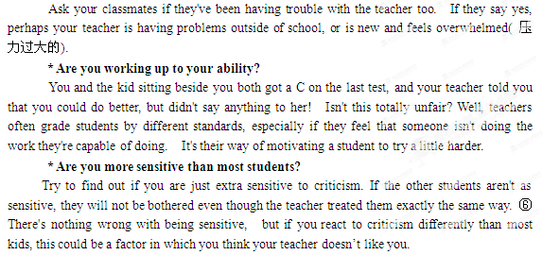 l. The writer thinks that it ________that a teacher and a student don't get along.
A. causes no harm B. is unusual
C. often happens D. is dangerous
2. The purpose of the four questions in the passage is to________.
A. help students find out the reasons why don't get along wit
h their teachersB. help teachers find out the reasons why don't get along with their students
C .help students understand why it’s good to get along with their teachers
D. help teachers understand why it’s good to get along with their students
3.If only one boy is criticized in a teacher's class, the boy should________.
A. ask his classmates for help
B. think more about himself
C. ask himself the four questions
D. get somebody on his side
4. What would happen if a girl student isn't doing the work she is capable of doing?
A. She might have trouble in her teacher's class.
B. She might wonder if her teacher gave her lower grades.
C. She might be graded by another standard.
D. She might mistake her teacher's inspiring words for criticism.
5. What's the writer's attitude towards being sensitive?
A. Positive. B. Negative. C. Neutral. D. Critical.

C篇：1.C。 第一段说如果你觉得老师不喜欢你，你可不是唯一的一个，师生之间有时候会有个性冲突，就像任何两个人关系处不好一样；毕竟，老师也有缺点。由此判断，作者认为师生之间处不好关系是一件很自然也是经常会有的事情。
2．A。 本题首先要从全文判断出作者是为学生所写。第二段作者说绝大多数时候，师生之间处不好关系的原因会有所不同，多种多样，因此你需要弄清到底是老师真地不喜欢你呢还是其它原因。接下来说这儿有几个问题，问问你自己吧，由行文逻辑可知作者提供这些问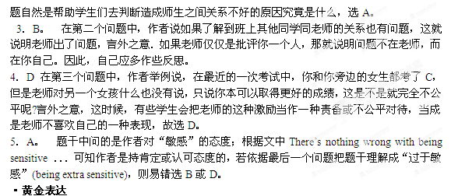①Guaranteed salaries, Smith argued, were the enemy of hard work; and when the academics were lazy and incompetent, the students were similarly lazy. 有保证的薪水，史密斯认为，是努力工作的敌人，在那个时刻，学院很懒，没有竞争力，学生们也很懒。
②Therefore, it is the individual, not the government, who should pay for their university education. 因此，是个人而不是政府，应该向大学教育买单。
③Both sides want peace, but neither feels it has any power to stop the conflict.双方都想和平，但是哪一方都感觉没有能力来制止这场冲突。
④Unfortunately, as long as long as parents and teens continue to assume that they know more than the other, they’ll continue to fight these battles forever and never make any real progress .不幸的是，只要父母和孩子认为自己知道得比对方多得话，他们就永远为战斗下去，不会取得任何进展。
⑤The more children get connected with talking, listening, reading and writing, the easier it is for them to become active readers. 孩子接触谈话，阅读，读书和写作越多，对于他们来说成为主动的读书人就越容易。
⑥There's nothing wrong with being sensitive, but if you react to criticism differently than most kids, this could be a factor in which you think your teacher doesn’t like you. 敏感没什么，但是如果你对批评表现得比别人格外不同的话，这可能就是老师不喜欢你的一个因素了。
·单词百宝箱
individual n.
The purpose of the law is to protect the right of the individual.该法律目的是为了保护个人权利。
guarantee v. 保证
We can't guarantee our workers' regular employment.我们不能保证我们的工人经常受雇。
adolescent n. 青少年，青春期
The adolescent crisis is most important.青春期易出现的问题是非常重要的。
tendency n. 趋势，趋向
There is a tendency to use plastics in place of metals at present.目前出现了用塑料代替金属的倾向。
outlook n. 观点，见解
He has a broad outlook on life.他的人生观十分豁达。
complex adj. 复杂的
He had not a particularly complex mind.他的头脑并不十分复杂。
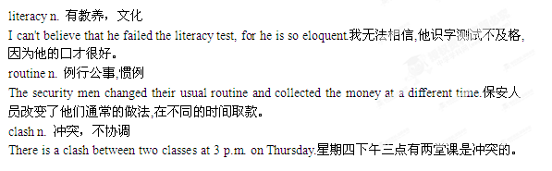

***********************************************************结束

