高考英语复习自选训练 阅读理解38

A

The fridge is considered a necessity. It has been so since the 1960s when packaged food first appeared with the label:“store in the refrigerator”
In my fridgeless Fifties childhood, I was fed well and healthily. The milkman came daily, the grocer, the butcher, the baker, and the ice-cream man delivered two or three times a week. The Sunday meat would last until Wednesday and surplus (剩余) bread and milk became all kinds of cakes. Nothing was wasted, and we were never troubled by rotten food. Thirty years on, food deliveries have ceased, fresh vegetables are almost unobtainable in the country.
The invention of the fridge contributed comparatively little to the art of food preservation. A vast way of well-tried techniques already existed —natural cooling, drying, smoking, salting, sugaring, bottling….
What refrigeration did promote was marketing-marketing hardware and electricity, marketing soft drinks, marketing dead bodies of animals around the globe in search of a good price.
Consequently, most of the world's fridges are to be found, not in the tropics where they might prove useful, but in the wealthy countries with mild temperatures where they are climatically almost unnecessary. Every winter, millions of fridges hum(嗡嗡响) away continuously, and at vast expense, busily maintaining an artificially-coo1ed space inside an artificially-heated house —while outside, nature provides the desired temperature free of charge.
The fridge's effect upon the environment has been evident, while its contribution to human happiness has been insignificant. If you don't believe me, try it yourself, invest in a food cabinet and turn off your fridge next winter. You may miss the hamburgers, but at least you'll get rid of that terrible hum.
41. The statement “In my bridgeless Fifties childhood, I was fed well and healthily.” in Para. 2 suggests that .
A. the author was well-fed and healthy even without a fridge in his fifties
B. the author was not accustomed to use fridges even in his fifties
C. there was no fridge in the author's home in the 1950s
D. the fridge was in its early stage of development in the 1950s
42. Why does the author say that nothing was wasted before the invention of fridges?
A. People would not buy more food than was necessary.
B. Food was delivered to people two or three times a week.
C. Food was sold fresh and did not get rotten easily.
D. People had effective ways to preserve their food.
43. Who benefited the least from fridges according to the author?
A. Inventors. B. Consumers. C. Manufacturers. D. Traveling salesmen.
44. Which of the following phrases in the fifth paragraph indicates the fridge’s negative effect on the environment?
A.“Hum away continuously”. B.“Climatically almost unnecessary”.
C. “Artificially-cooled space”. D.“With mild temperatures”.
45. What is the author’s overall attitude toward fridges?

A. Neutral. B. Critical.
C. Objective D. Compromising.

参考答案 41-45. C D B A B
****************************************************结束

(5)
Last weekend, a girlfriend that I’ve known since college was visiting. As we left the airport, we had to stop at the grocery for a case of diet soda. On our way to lunch she asked me “Do you think that drinking diet soda makes you fat?”
“Depends on whom you ask,” I said. Last year, researchers from the University of Texas Health Science Center in San Antonio reported that adults who drink diet soda did not lose weight. They were actually more likely to become overweight than those adults who did not drink soda at all or those that drink regular soda. In fact, the more diet soda consumed, the more likely someone would become overweight. To be specific, there was a 41% increase in the risk of being overweight for every can or bottle of diet soda consumed daily.
In this study, researcher Sharon Fowler followed over 600 normal weight adults ages 25-64 over a seven to eight year period of time. She has a number of theories as to why weight gain may be a result of drinking a zero-calorie beverage:
- Artificial sweeteners may affect your body’s ability to judge how many calories you consume. When no calories are consumed, the body may continue to crave(渴望) what it expected and could lead to overeating.
2. Some people give up regular sodas to justify their favorite dessert and still take in too many calories. A regular soda contains about 150 calories while your dessert may be double that in calories easily.
3. For others who were gaining weight already, switching to diet soda wasn’t enough to stop the gain.
Since her first piece of research, Fowler has tracked another 2000 people with similar results. Do the faux sweet products induce people to want more sweets? Fowler suggests that perhaps it’s not the soft drinks themselves that cause weight gain but that there is some link between diet soda drinking and overweight.
- Why do people give up regular soda and take diet one according to Fowler’s research?
A. Some want to gain weight.
B. Some want excuses to have dessert.
C. Some mistake diet soda as no-calorie drink.
D. Diet soda can help people lose weight.
- Which of the following statements is the result of Fowler’s research?
A. Diet soda can directly cause people to gain weight.
B. Diet soda increases the risk of becoming overweight.
C. Diet soda actually contains more calories than regular soda.
D. Those who drink diet soda are 41% more likely to become fat.
3. Which can NOT explain the link between diet soda and overweight?
A. People overeat to satisfy the body’s needs for calories that diet soda lacks.
B. People also have foods containing more calories when they choose diet soda.
  - Diet soda has little effect on those who have become overweight already.
  - Diet soda is a sweetener that increases the body’s needs for calories.
  - 4. What can we learn from the passage?
A. Only overweight adults are involved to see if diet soda can help lose weight.
B. The research lasted many years and over 2000 people took part in it.
C. Diet soda has opposite effect on those who take it to lose weight.
D. Sharon Fowler is the first to find drinking diet soda leads to overweight.
5. What does the underlined word “induce” probably mean?
A. cause B. reduce C. advise D. inspire

参考答案 1---5 B B D C A
*****************************************************结束

阅读理解-世界与环境
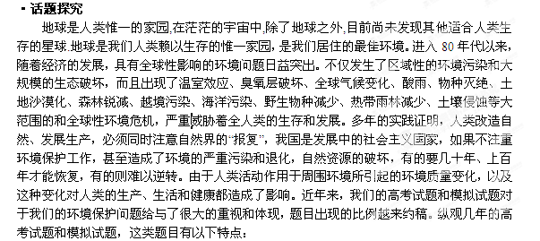1. 我们居住的地球的环境特点以及很多自然灾害的现象。
2. 由于人类的破坏，地球变化带来的一些事件。
3. 一些提倡保护我们居住的环境，提高环保意识的各种环保行为和活动。
4. 介绍一些环保的产品，及其带来的好处。
5. 保持环境的自然、进行有效再循环的话题。

·链接高考
链接1. （2012山东卷）
The Pacific island nation of Nauru used to be a beautiful place. Now it is an ecological disaster area. Nauru's heartbreaking story could have one good consequence—other countries might learn from its mistakes.
For thousands of years, Polynesian people lived on the remote island of Nauru, far from western civilization, the first European to arrive was John Feam in 1798. He was the British captain of the Hunter, a whaling ship, He called the island Pleasant Island.
However, because it was very remote, Nauru had little communication with Europeans at first. Then whaling ships and other traders began to visit, bringing guns and alcohol. These elements destroyed the social balance of the twelve family groups on the island. A ten-year civil war started, which reduced the population from 1,400 to 900.
Nauru's real troubles began in 1899 when a British mining company discovered phosphate(磷酸盐) on the island. In fact, it found that the island of Nauru was nearly all phosphate, which is a very important fertilizer for fanning. The company began mining the phosphate.
A phosphate mine is not a hole in the ground; it is a strip mine. When a company strip-mines, it removes the top layer of soil Then u takes away the material it wants. Strip-mining totally destroys die land. Gradually, the lovely island of Nauru started to look like the moon.
In 1968, Nauru became one of the richest countries in the world. Every year the government received millions and millions of dollars for its phosphate
Unfortunately, the leaders invested the money unwisely and lost millions of dollars. In addition, they used millions more dollars for personal expenses. Soon people realized dial they had a terrible problem—their phosphate was running out. Ninety percent of their island was destroyed and they had nothing. By 2000, Nauru was almost financially ruined. Experts say that it would take approximately $433,600,000 and more than 20 years to repair the island. This will probably never happen.

56. What might be the author's purpose in writing the text?
A. To seek help for Nauru's problems.
B. To give a warning to other countries.
C. To show the importance of money.
D. To tell a heartbreaking story of a war.
57. What was Nauru like before the Europeans came?
A. Rich and powerful. B. Modem and open.
C. Peaceful and attractive. D. Greedy and aggressive.
58. The ecological disaster in Nauru resulted from______ .
A. soil pollution B. phosphate overmining
C. farming activity D. whale hunting
59. Which of the following was a cause of Nauru's financial problem?
A. Its leaders misused the money.
B. It spent too much repairing the island.
C. Its phosphate mining cost much money.
D. It lost millions of dollars in the civil war.
60. What can we learn about Nauru from the last paragraph?
A. The ecological damage is difficult to repair.
B. The leaders will take the experts' words seriously.
C. The island was abandoned by the Nauruans.
D. The phosphate mines were destroyed.
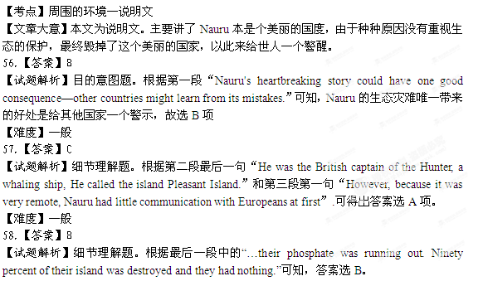【难度】一般
59.【答案】A
【试题解析】细节理解题。根据最后一段前两句和最后三句可知，Nauru的领导者对金钱的错误使用致使这个国家陷入了财政困难，故答案选A。


