高考英语复习自选训练 阅读理解40

A
People
People is America's No.1 magazine about fascinating people.It's a guide to who and what's hot in the arts，science，business，politics，television，movies，books，music and sports.It is published weekly.
Publisher：The Time Inc.Magazine Company
Cover Price：$211.47
Our Price：$117.00
Issues：53 issues/12 months
Lucky
Lucky is the shopping magazine with the best buys，and the fashion tips you'll need before you hit the stores.What makes Lucky really special is that it gets you the information you need before anyone else has it.
Publisher：Conde Nast Publications Inc.
Cover Price：$35.40
Our Price：$15.00
Issues：12 issues/12 months
Parents
The most trusted magazine for parents who want to raise smart，loving and selfconfident children.Each issue has agespecific childdevelopment guidance，advice on your child's health and safety，and the best ways to encourage your child's learning.
Publisher：Meredith Corporation
Cover Price：$42.00
Our Price：$9.97
Issues：12 issues/12 months
Entertainment
This magazine covers movies，television，music，Broadway stage productions，books，and popular culture.Unlike celebrityfocused_magazines like People，its main concentration is on entertainment media and reviews.It's intended for a more general audience.
Publisher：The Time Inc.Magazine Company
Cover Price：$199.50
Our Price：$38.95
Issues：57 issues/12 months
1．Which of the following targets common readers?
A．Lucky. B．Entertainment.
C．Parents. D．People.
2．According to the passage，what makes Lucky so special?
A．Its exclusive information related to shopping.
B．Its pictures of fashion stores.
C．The access it provides to bargains.
D．Its competitive price.
3．Celebrityfocused magazines are probably ones focusing on ________.
A．political events
B．festivals and celebrations
C．hot events and famous stars
D．television programs
4．You're most likely to find the above information ________.
A．in an educational magazine
B．on a magazine club website
C．in a guide to magazines
D．in a magazine sales report
5．________ costs the subscriber least.
A．Lucky B．Parents
C．People D．Entertainment
*********************************************************结束

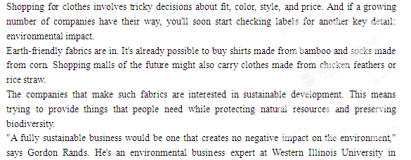Macomb. "I don't think such a business exists yet, but theoretically（理论上） it's very possible. And companies are moving in this direction."
So, scientists are now looking for new ways to make fabrics for clothes that are good both for your image and for Earth.
In the past few years, textile scientist Yiqi Yang of the University of Nebraska in Lincoln has figured out how to make yarn out of cornhusks, chicken feathers, and rice straw (part of the rice plant). All three are agricultural by-products that usually end up in the trash.
"We already have a problem with how to get rid of these waste products," Yang says. "Instead, let's use them to make beautiful materials."
The process involves chemical reactions that break down the raw materials into fibers（光纤）, followed by cleaning. The scientists then spin the fibers into yarn（纱线）, which they use to make fabrics.
⑦Clothes made from farm waste are still years away from hitting the stores, but clothes made from organic or recycled fabrics and products made from coconut, bamboo, and corn sugar are already available in many places.
Simply by choosing carefully how you get dressed in the morning, you can help decide Earth's future.
1. From what Gordon Rands says, we know his attitude about sustainable business is ______.
A. confident B. disappointed C. angry D. critical
2. It is already likely that we can buy products made from ______.
A. bamboo, corn and feathers
B. chicken feathers and rice straw
C. coconut, bamboo, and corn sugar
D. cornhusks and rice straw
3. A company which is interested in sustainable development will_______.
A. provide things that people need
B. have no bad effect on earth
C. make products at a low cost
D. make trash into products
4. The best title of this passage would be _______.
A. Earth Friendly Fabrics
B. Trash or Treasure
C. A New Trend to sustainable development
D. Change in choosing clothes
5. The last paragraph shows that ________.
A. we have more chances to choose what we wear
B. we should choose earth friendly clothes
C. our clothes will be made of more materials
D. we will spend more time deciding what to wear

- 选A。
2、C。细节理解题。从倒数第二段可知，coconut（椰子）, bamboo（竹子）, 和 corn sugar（玉米葡糖）制作的产品已经能买到，但是由玉米、稻草秸秆和羽毛等东西做原料的产品还在实验阶段。
3、B。从Gordon Rands给可持续性发展下的定义可知，如果一个公司实现了可持续性发展，那它就不会对地球产生任何坏的影响。A、D项叙述片面，C项文中未提及。
4、A。全文是围绕环保织品展开的，讲到了这类织品的来源，制作过程和环保作用。所以其他题目只侧重了文章中某个部分的内容，不够全面。
5、B。最后一段的意思为：早晨要仔细选择穿什么样的衣服，你会影响地球的将来，该段照应第一段，即我们要穿环保的衣服。
·黄金表达
- A rainforest is an area covered by tall trees with the total high rainfall spreading quite equally through the year and the temperature rarely dipping below l6℃. 热带雨林是这么的一个地区，被大树所覆盖，降雨量一年四季都很大，气温很少到16度以下。
②Secondly，cutting large sections of rainforests may provide a good supply of wood right now，but in the long run it actually reduces the world’s wood supply. 第二，看法部分热带雨林也许现在会提供一些木材，但是从长远的循环来看，它的确会减少世界的木材供给。
③We are dealing with the results of that over-consumption in the greenest way possible, but it would be far better if we did not need to bring so much material home in the first place.我们正在经历这样的一些过渡包装的结果，也许它是很绿色的一种方式，但是如果我们首先不需要带那么多材料回家的话，那将会好的多。
④Two thirds of customers say that environmental considerations inform their purchases to the same degree as they did a year ago, while more than a quarter say that they are now even better aware of the environmental effect on what they buy. 现在三分之二的顾客在购物时对环境的考虑比前一年程度加深了，而有超过四分之一的顾客说他们更加意识到对于他们买的东西对于环境的影响。
⑤So far the program has recycled more than 459 tons of paper and saved over $22,000 in trash-disposal expenses. 迄今为止，这个项目已经再循环了459吨的纸张，并且节约了2万2千多废物处理的费用。
⑥Because buildings need enormous quantities of the Earth's resources in their construction and 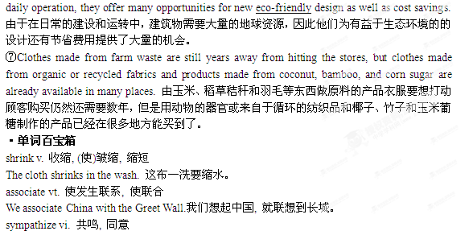We have long sympathize with the aims of Green Party. 我们长期以来一致支持绿党保护生态环境的目标。
motivation n.动机，内在要求
The stronger the motivation, the more quickly a person will learn a foreign language. 一个人学外语的内在要求越高, 那么他就学得越快。
trash n. 垃圾
He thinks most modern art is trash.他认为现代艺术大多是糟粕。
accomplish vt.完成, 达到, 实现
He can accomplish more in a day than any other boy in his class.他一天所完成的工作比他班上其他的孩子都多。
conserve vt. 保存, 保藏
The government in the city calls to conserve our national heritage in the face of bewildering change.这个城市的政府呼吁大家要保护我们的民族遗产。
renovate v.革新, 刷新, 修复
The house has been renovated three years earlier.这所房子三年前就已翻新。
label n.标签, 签条, 商标, 标志
In order to find our luggage easily , we put labels on them. 为了好找到我们的行李，我们在他们上面加了标签。
impact n. 碰撞, 冲击, 冲突, 影响, 效果
The scientists are still measuring the impact of automation on the lives of factory workers. 科学家们仍然在测试自动化对工厂工人生活的影响。
fabric n.织品, 织物, 布, 结构, 建筑物,构造
This is a fine fabric for ladies' dresses.这是一种适于做女服用的织法精美的布料。
sustainable adj.可以忍受的, 足可支撑的, 养得起的
The sea wall sustains the shock of the waves.海堤能抵挡海浪的冲击。
**************************************************************结束

