高考英语复习自选训练 阅读理解41

A
(NEW YORK) A French tourist highly praised for rescuing a twoyearold girl in Manhattan said he didn't think twice before diving into the freezing East River.
Tuesday's Daily News said 29yearold Julien Duret from France was the man who left the spot quickly after the rescue last Saturday.
He lifted the little girl out of the water after she fell off the bank at the South Street Seaport museum. He handed the girl to her father, David Anderson, who had dived in after him.
“I didn't think at all，” Duret told the Daily News. “It happened very fast. I reacted very fast.”
Duret, an engineer on vacation, was walking with his girlfriend along the pier(码头) when he saw something falling into the water.
He thought it was a doll, but realized it was a child when he approached the river. Immediately, he took off his coat and jumped into the water.When he reached the girl, she appeared lifeless, he said. Fortunately, when she was out of the water, she opened her eyes.
Anderson said his daughter slipped off the bank when he was adjusting his camera. An ambulance came later for her, said Duret, who was handed dry clothes from onlookers. Duret caught a taxi with his girlfriend shortly after.
The rescue happened on the day before he left for France. Duret said he didn't realize his story of heroism had greatly moved New York until he was leaving the city the next morning.“I don't really think I'm a hero，” said Duret. “Anyone would do the same thing.”
1．Why was Duret in New York?
A．To meet his girlfriend.
B．To spend his holiday.
C．To work as an engineer.
D．To visit the Andersons.
2．What did Duret do shortly after the ambulance came?
A．He was interviewed by a newspaper.
B．He went to the hospital in the ambulance.
C．He disappeared from the spot quickly.
D．He asked his girlfriend for his dry clothes.
3．Who dived after Duret into the river to save the little girl?
A．David Anderson.
B．A passerby.
C．His girlfriend.
D．A taxi driver.
4．Which of the following is TRUE according to the passage?
A．Duret thought twice before he jumped into the cold water.
B．Duret dived into the water before the girl's father.
C．The rescue happened on the day Duret left for France.
D．Duret didn't think he was brave enough to be a hero.
5．What is probably the headline of this news report?
A．A Careless Father
B．A Poor Girl
C．Warmhearted Onlookers
D．Brave Frenchman Found
******************************************************结束

阅读理解推断题解题指导
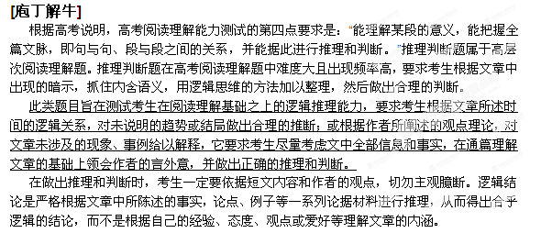例1（2012全国卷1） Last night I was driving from Harrisburg to Lewisburg，distance of about eighty miles. It was late. Several times I got stuck behind a slow-moving truck on a narrow road with a solid white line on my left, and I became increasingly impatient.
At one point along an open road, I came to a crossing with a traffic light. I was alone on the road by now, but as I drove near the light, it turned red and I made a stop. I looked left, right and behind me. Nothing. Not a car, no suggestion of car lamps, but there I sat, waiting for the light to change, the only human being for at least a mile in any direction.
I started wondering why 1 refused to run the light I was not afraid of being caught, because there was clearly no policeman wound, and there certainly would have been no danger in going through it..
Much later that night, the question of why I'd stopped for that light came back to me. I think I
stopped because it's part of a contract(契约)we all have with each other. It's not only the law, but it is an agreement we have, and we trust each other to honor it: we don't go through red lights.
Trust is our first inclination(倾向).Doubting others does not seem to be natural to us. The whole construction of our society depends on mutual(相互)trust, not distrust We do what we say we'll do; we show up when we say we'll show up; and we pay when we say we'll pay. We trust each other in these matters, and we're angry or disappointed with the person or organization that breaks the trust we have in them.
I was so proud of myself for stopping for the red light that night.

65. The event made the author strongly believe that .
A. traffic rules may be unnecessary
B. doubting others is human nature
C. patience is important to drivers
D. a society needs mutual trust
[点拨] D 根据短文第5段，不难判断作者相信一个社会需要互相信任。因此，正确答案为D选项。
66. Why was the author proud of himself?
A He kept his promise. B. He held back his anger.
C. He followed his inclination. D. He made a right decision.
[点拨] D 根据短文容易判断作者引以为豪的是对未闯红灯一事所做的决定。因此，正确答案为D选项。

