高考英语复习自选训练 阅读理解42

(1)
The world itself is becoming much smaller by using modern traffic and modern communication means. Life today is much easier than it was hundreds of years ago, but it has brought new problems. One of the biggest problems is pollution. To pollute means to make things dirty. Pollution comes in many ways. We see it, smell it, drink it and even hear it.
Man has been polluting the earth. The more people, the more pollution. Many years ago, the problem was not so serious because there were not so many people. When the land was used up or the river was dirty in one place, man moved to another place. But this is no longer true.
Man is now slowly polluting the whole world.
Air pollution is still the most serious. It’s bad for all living things in the world, but it is not the only one kind of pollution. Water pollution kills our fish and pollutes our drinking water. Noise pollution makes us angry more easily.
Many countries are making rules to fight pollution. They stop people from burning coal in houses and factories in the city, and from putting dirty smoke into the air. Pollution by SO2 is now the most dangerous kind of air pollution. It is caused by heavy traffic. We are sure that if there are fewer people driving, there will be less air pollution.
The earth is our home. We must take care of it. That means keeping the land, water and air clean. And we must take care of the rise in pollution at the same time.
1. _______, our world is becoming much smaller.
A. Because of the rise in pollution
B. Thanks to science development
C. Because the earth is being polluted day and night
D. Because the earth is blown away by the wind every year
2. Hundreds of years ago, life was __________ it is today.
A. much easier than B. as easy as
C. much harder than D. as hard as
3. Pollution comes in many ways. We can even hear it. Here “it” means _______.
A. rubbish(垃圾) B. noise pollution
C. air pollution D. water pollution
4. Air pollution is the most serious kind of pollution because _______.
A. it makes much noise
B. it makes us angry more easily
C. it makes our rivers and lakes dirty
D. it’s bad for all living things in the world
5. Which of the following is NOT true?
A. Many countries are making rules to fight pollution.
B. The pollution of the earth grows as fast as the world population does.
C. The problem of pollution is not so serious because there are not so many people living on the earth.
D. If people could go to work by bus or bike instead of car or motorbike, it would be helpful in fighting against the problem of SO2.
【答案与解析】本文谈到全球环境污染这个问题，同时号召人们来为我们的家园——地球出一份力，减少污染。
1. B。由文章的首句我们得知：世界变小是由于modern traffic and modern communication means(现在的交通运输工具和沟通工具的使用)，而这一切都要靠科学技术的发展，据此我们可以推出答案是B。
2. C。原文的第2句告诉我们Life today is much easier than it was hundreds of years ago(今天的生活比以前容易得多)，反过来说，以前的生活一定比今天的艰难，所以答案是C。
3. B。在众多选项中，只有选项B(noise pollution噪音污染)是听得见的。
4. D。我们根据第4段的第1, 2句Air pollution is still the most serious. It’s bad for all living things in the world…，可以得知空气污染之所以最为严重，正如选项D(它是危害全世界生物的)所说的那样。
5. C。选项C可以在原文第2段的第2句找到，但它缺少了前提条件many years ago(以前不严重而现在严重)，所以选项C是错误的]
*********************************************************结束

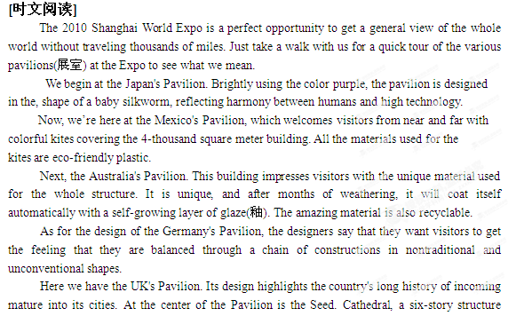formed by 60-thousand transparent sticks that sway in the wind and contain fiber-optic filaments(光纤丝).
Here at the Joint Pavilion we can visit exhibitions of 42 African countries all in one place. The facility aims to represent the cultural diversity, solidarity, and the bright future of the African countries.
There is still so much more for you to discover at the Shanghai World Expo. You’ll find it worthwhile to make your plans to come, and then you can decide what pavilions you want to see next.
1. What can be a best title for the passage?
A. The most popular travel site. B. World tour at the Shanghai Expo.
C. Which pavilion is most attractive? D. A general guide to Shanghai Expo.
2. In the ________pavilion you will have the feeling of unusual.
A. Germany's B. UK's C. Japan's D. Mexico's
3. What do the pavilions of Mexico and Australia-have in common?
A. They both reflect harmony between humans and technology.
B. They are both built in large area and painted colorful.
C. Their building materials are eco-friendly.
D. Their pavilions are of the same building material .
4. In the African Pavilion, you will know little about their
A. cultural diversity B. future life
C. national solidarity D. social security
5. The writer writes the passage in order to ________.
A. introduce different foreign architectures to us
B. tell apart which is the best pavilion by comparison
C. attract more people to Shanghai World Expo
D. give a brief description about some countries in the world .
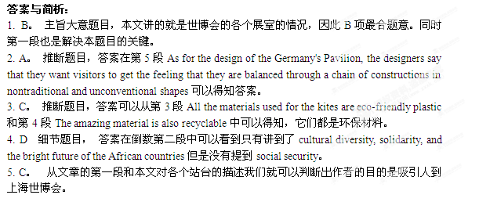

**********************************************************结束

